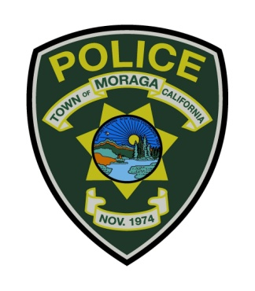

TOWN OF MORAGA POLICE DEPARTMENT

329 Rheem Boulevard, Moraga, CA 94556
(925) 888-7055 ext. 0

Jon King
Chief of Police

The Town of Moraga is accepting applications for the position of

Police Officer for Lateral and Academy Graduates

We have an expedited hiring process for Lateral applicants.

Application Deadline: Open Until Filled

THE MORAGA COMMUNITY

The Town of Moraga is an affluent suburb of approximately 16,000 residents. Moraga is located in central Contra Costa County, approximately 30 minutes from San Francisco and the Sacramento Delta area, and encompasses an area of approximately 9.5 square miles. Moraga employs a Council-Manager form of government, serving a predominantly residential community within a semi-rural setting. The public school systems which serve Moraga are highly rated within the California public school system, and Saint Mary’s College is located within the Town limits. The residents of the community are actively involved in community projects and are committed to maintaining a safe and serene environment.

POSITION OF POLICE OFFICER

As a Moraga Police Officer, you will be required to respond to emergency and non-emergency calls for service; enforce laws and ordinances; monitor and control traffic; prevent crime; administer first aid when needed; make arrests; serve warrants and subpoenas; interview victims and witnesses; interrogate suspects; process crime scenes for evidence; process and transport prisoners; investigate crimes and prepare comprehensive written reports; testify in court; present cases for prosecution to the District Attorney’s office; speak before public groups on job related topics and provide other services as needed.

THE DEPARTMENT

The Moraga Police Department, formed in 1979, has developed an excellent reputation among residents and the law enforcement community. Moraga has consistently maintained one of the lowest crime rates in California by promoting active patrol procedures and crime prevention education. The department has a current authorization for 12 sworn positions, 1 full time civilian Support Services Coordinator, and a part time Police Services Technician. The department is also supported by dedicated reserve officers and police cadets.

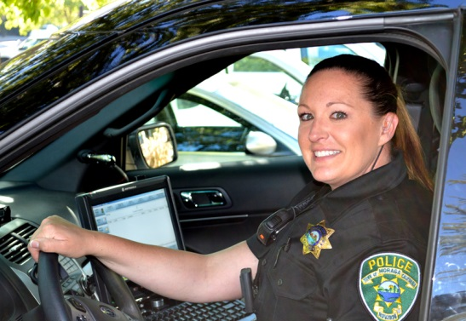
COMPENSATION AND BENEFITS

Salary: $100,260 – $127,944
(Effective 07/01/24 – includes POST Certificate incentives)

Retirement: CalPERS 2% @ 50 for “classic” members; 2.7% @ 57 for new PEPRA members
Bachelors Degree 3.0%
Graveyard shift differential 4.0%
12 hour work shifts for a total of 84 hours bi-weekly
13 paid holidays paid in bi-weekly installments (equals 5% of annual salary)
Sick leave is accrued at 3.69 hours bi-weekly
Paid vacation is accrued at the rate of 80 hours per year; increases with service time.
Educational Reimbursement - Town pays for tuition and fees for approved job-related college courses in a Bachelor or Masters Degree program up to the equivalent costs at a Cal State University.
Uniform allowance paid to employee; $1,200 per year in bi-weekly installments.
Compensatory time may be accrued to a maximum of 80 hours (60 hours available for cash-out each year).
The Town provides medical insurance, including a full family Kaiser HMO Gold medical plan.
The Town provides dental, vision, Life, LTD & AD&D insurance.

MINIMUM QUALIFICATIONS

Minimum age of 21 at time of appointment
Minimum of 60 semester or 90 quarter units of college course work is required. Credit may be allowed for prior law enforcement experience. Bachelor’s degree is desirable.
Must be in excellent physical health with no physical, emotional, or mental condition which might adversely affect performance.
Must meet POST vision standards and requirements; must have normal hearing.
Must possess a valid California driver’s license.
Must pass oral interview, medical examination, psychological examination, polygraph and an extensive background investigation.
Applicant will be screened using a written exercise and oral interview.

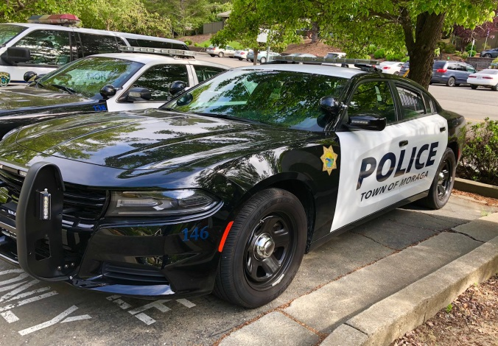
TO APPLY

Application deadline: Open Until Filled
Candidates should apply on the CalOpps website using the following link https://www.calopps.org/job-search/moraga?keyword=moraga

Questions may be directed to Lieutenant Steve Borbely at (925) 888-7052, or emailed to borbely@moraga.ca.us Applicants may wish to visit the department’s web site for further information at
https://www.moraga.ca.us/285/Employment

